**Milestone 1: Set up your account**

**Activity 1: Sign up for a Zoho Books account and Login**

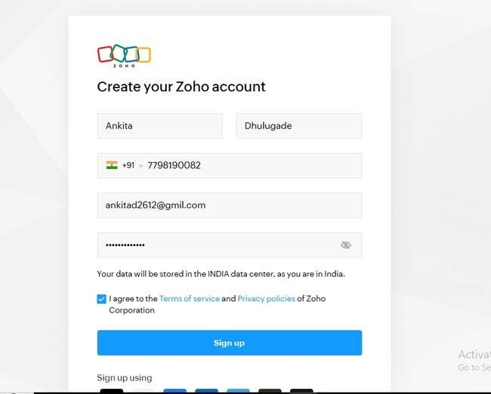

**Milestone 2: Service Creation:**

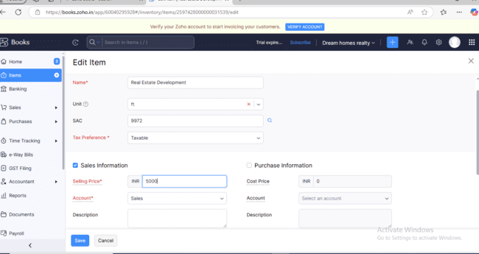**Activity 1: Creation**

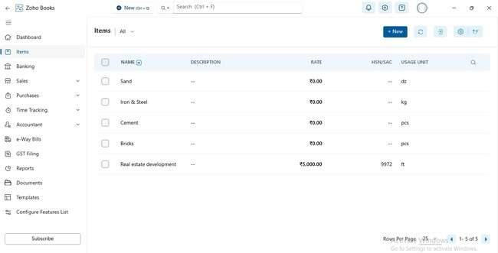**Activity 2: Rewiew of Items after Addition**

**Milestone 3: Vendors**

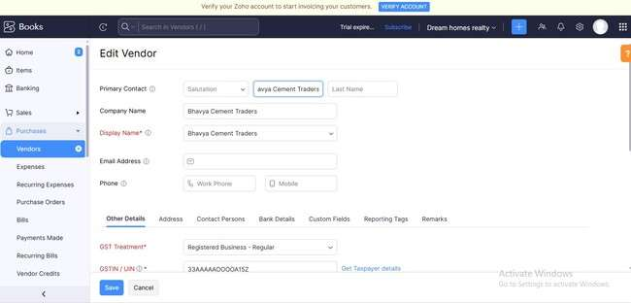**Activity 1: Vendors Creation**

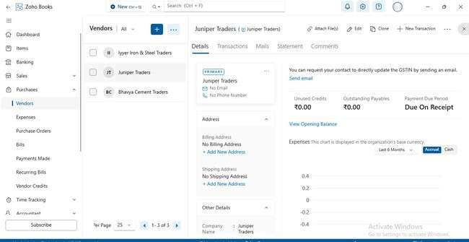**Activity 2: Review of Vendors List**

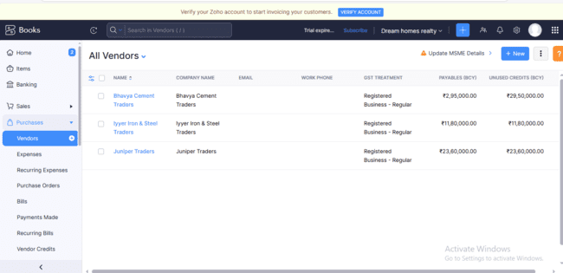

**Milestone 4: Purchases**

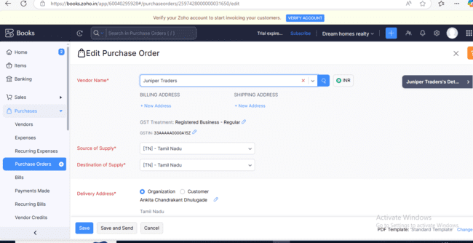**Activity 1: Purchase Order Creation**

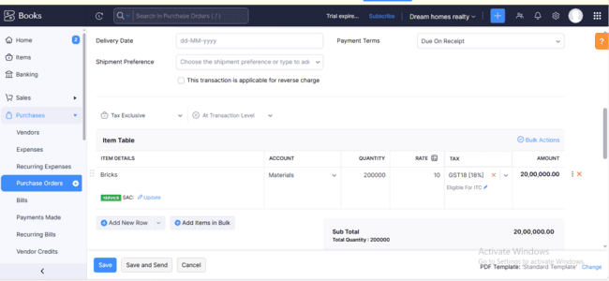

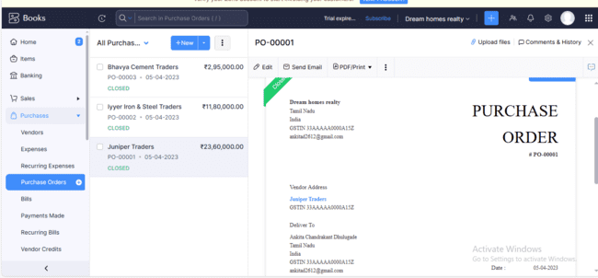**Activity 2: Purchase Order to Purchase Bills Convertion**

**Activity 3: Direct Vendor** **Purchases Bills Creation:** 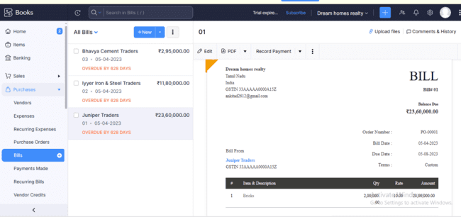

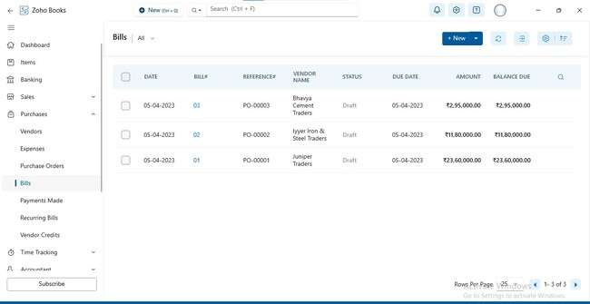**Activity 4: Reconciliation of Open & Outstanding Bills**

**Milestone 5: Customers**

**Activity 1: Customers Creation:** 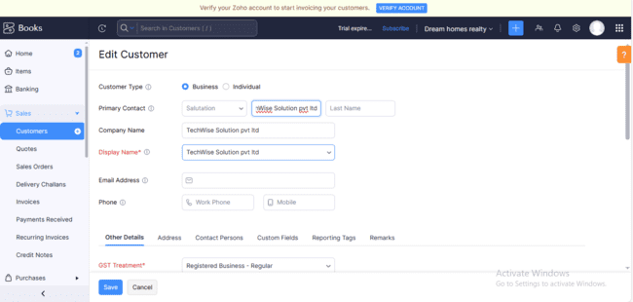

**Activity 2: Review the Customers List**

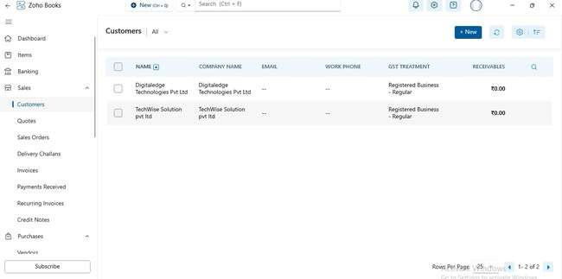

**Milestone 6: Sales**

**Activity 1: Sales Order Creation**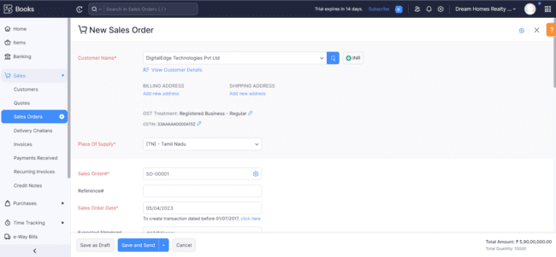

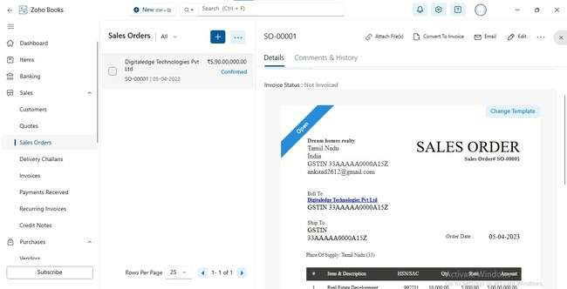**Activity 2: Sales Order to Sale Invoice Convertion**

**Activity 3: Direct Sale Invoices**

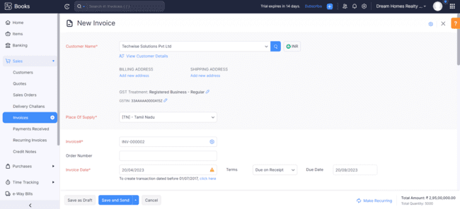

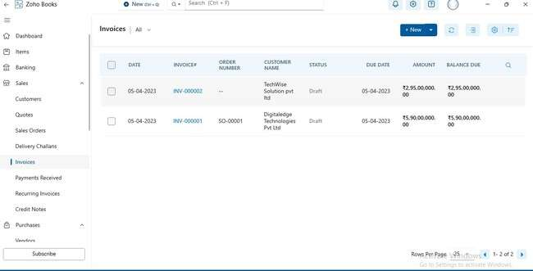**Activity 4: Reconciliation of Open Invoices**

**Milestone 7: Bank Account**

**Activity 1: Adding Bank Account**

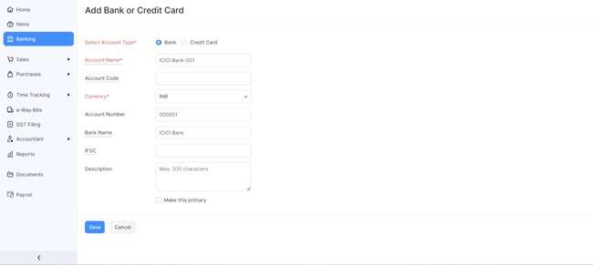

**Milestone 8: Accounts & Ledgers**

**Activity 1: Creation of New Accounts/Ledgers:**

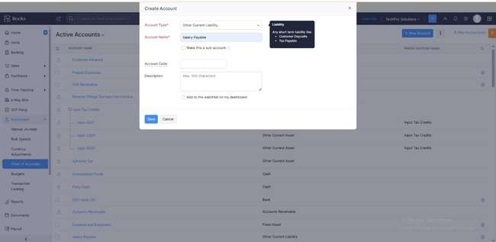

**Milestone 9: Journal Entries:**

**Activity 1: Recording of Journal Entries**

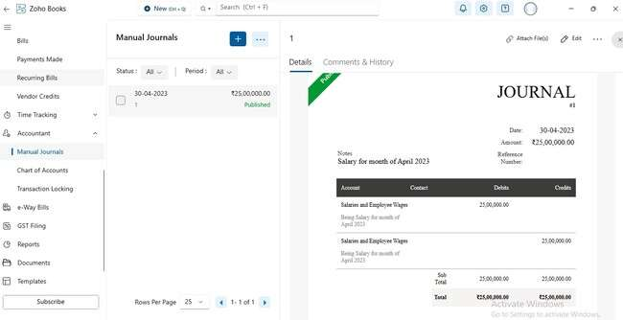

**Milestone 10: Expense & Bills**

**Activity 1: Expense & Bills Entry**

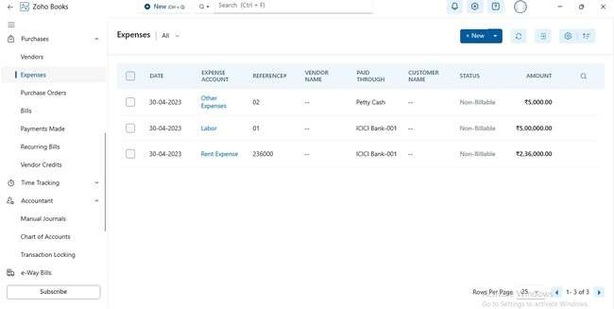

**Milestone 11: Bank Entries**

For Customer Payment:

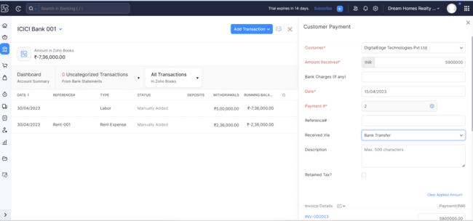

For Vendor Payment:

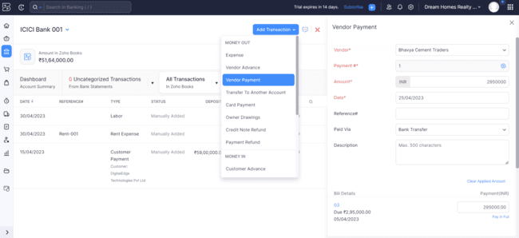

For Salary Payment pass the journal entry:

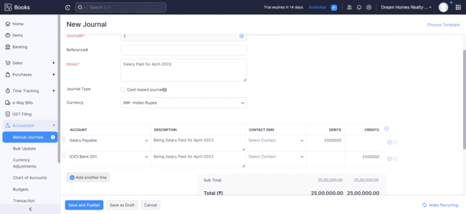

**Milestone 12: Financial Reports:**

**Activity 1: Profit and Loss Account**

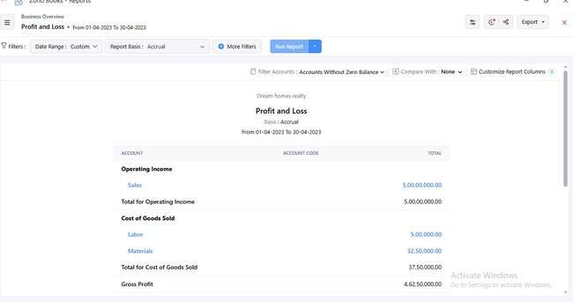

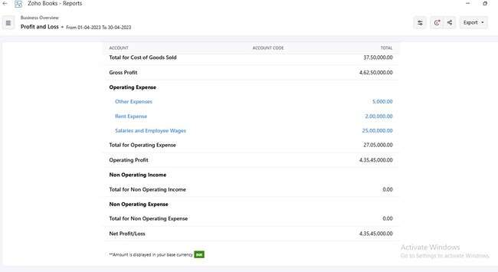

**Activity 2: Balance Sheet**

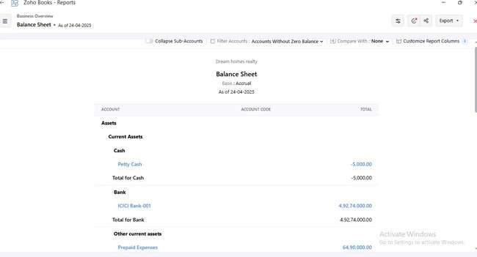

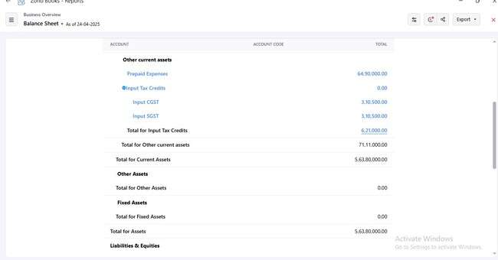

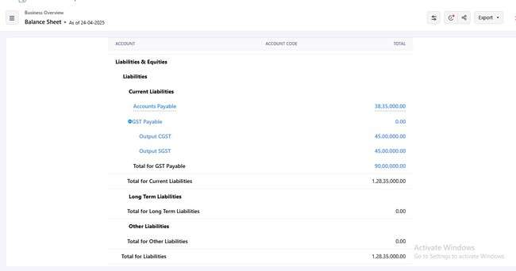

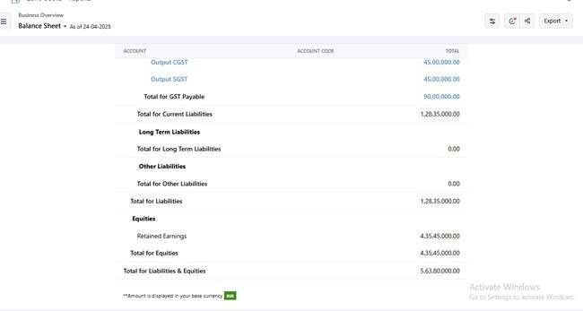

**Activity 3: GST Reports**

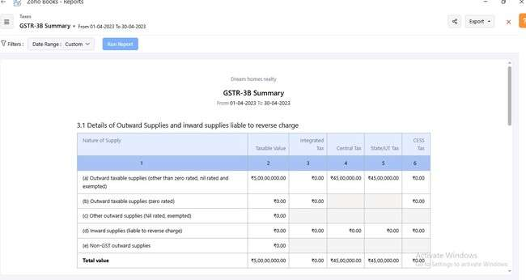

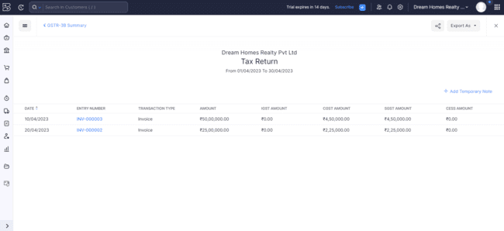

**Activity 4: Journal Report**

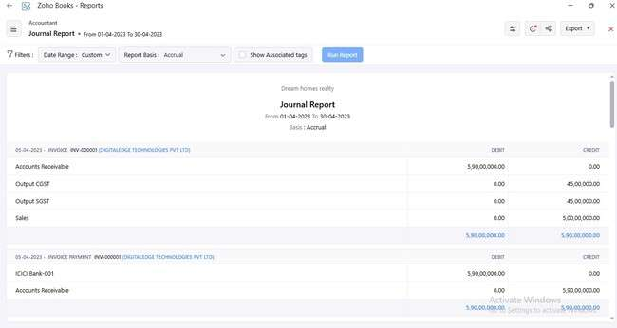

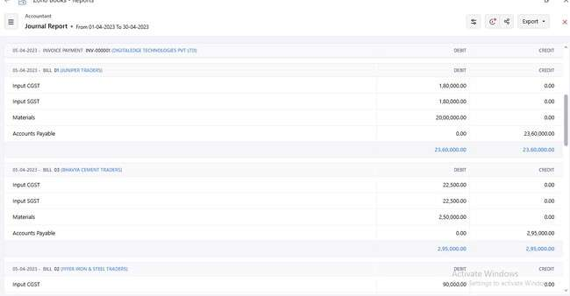

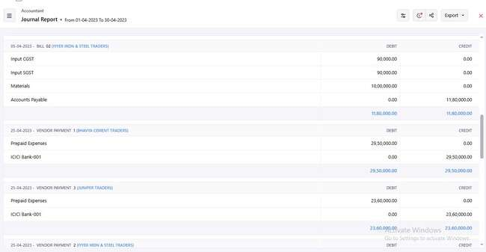

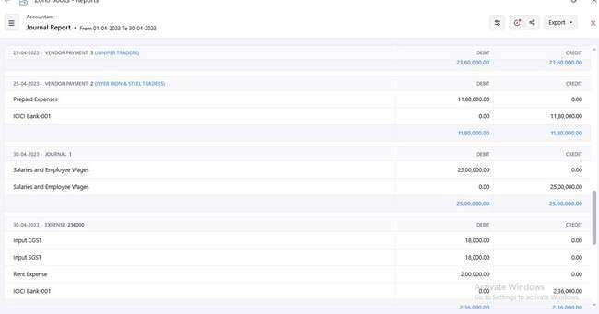

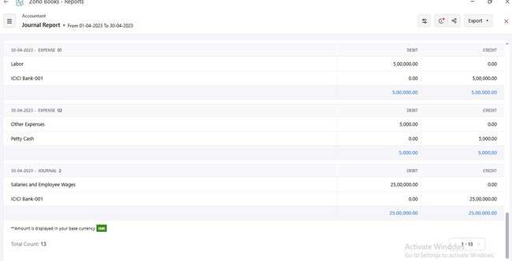

**Activity 5: Accounts Receivable Aging Details**

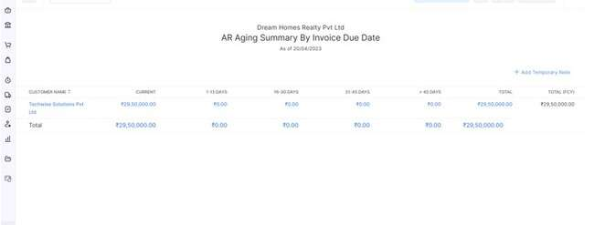

**Activity 6: Accounts Payable Aging Details**

